USER STORIES:

1. As a owner, i want to advertise my sport center, so more people can join the gym.
2. As a teenger, i want to book a soccer field, so i can play with my friends.
3. As a sportsman, i want to see where is located the sport center, so i can reach it easily.

FUNCTIONAL REQUIREMENTS:

1. The system shall allow the user to find all the sports structure in a selectable range of kilometres from his current position.
2. The system shall provide an option for the user to see if a sport center is busy in real-time.
3. The system shall display pictures of all sports structures that are currently in the system.

Get user current

position

Get the list of centers

Display center in

proximity order

Ask the user which

sport center they

wants to rent

Display availability

\*Log in

Get user choice

Confirm reservation

]

else

[

[

if not busy

]

Check if the center is

busy

Display message

Ask the user to write

the password

Verify password

Reject login

Update view

]

Authorized

[

]

[

Else

Wait 5s\* count

Increment invalid

login count

Ask the user to write

his username

Verify username

[

User not valid

]

[

Else

]

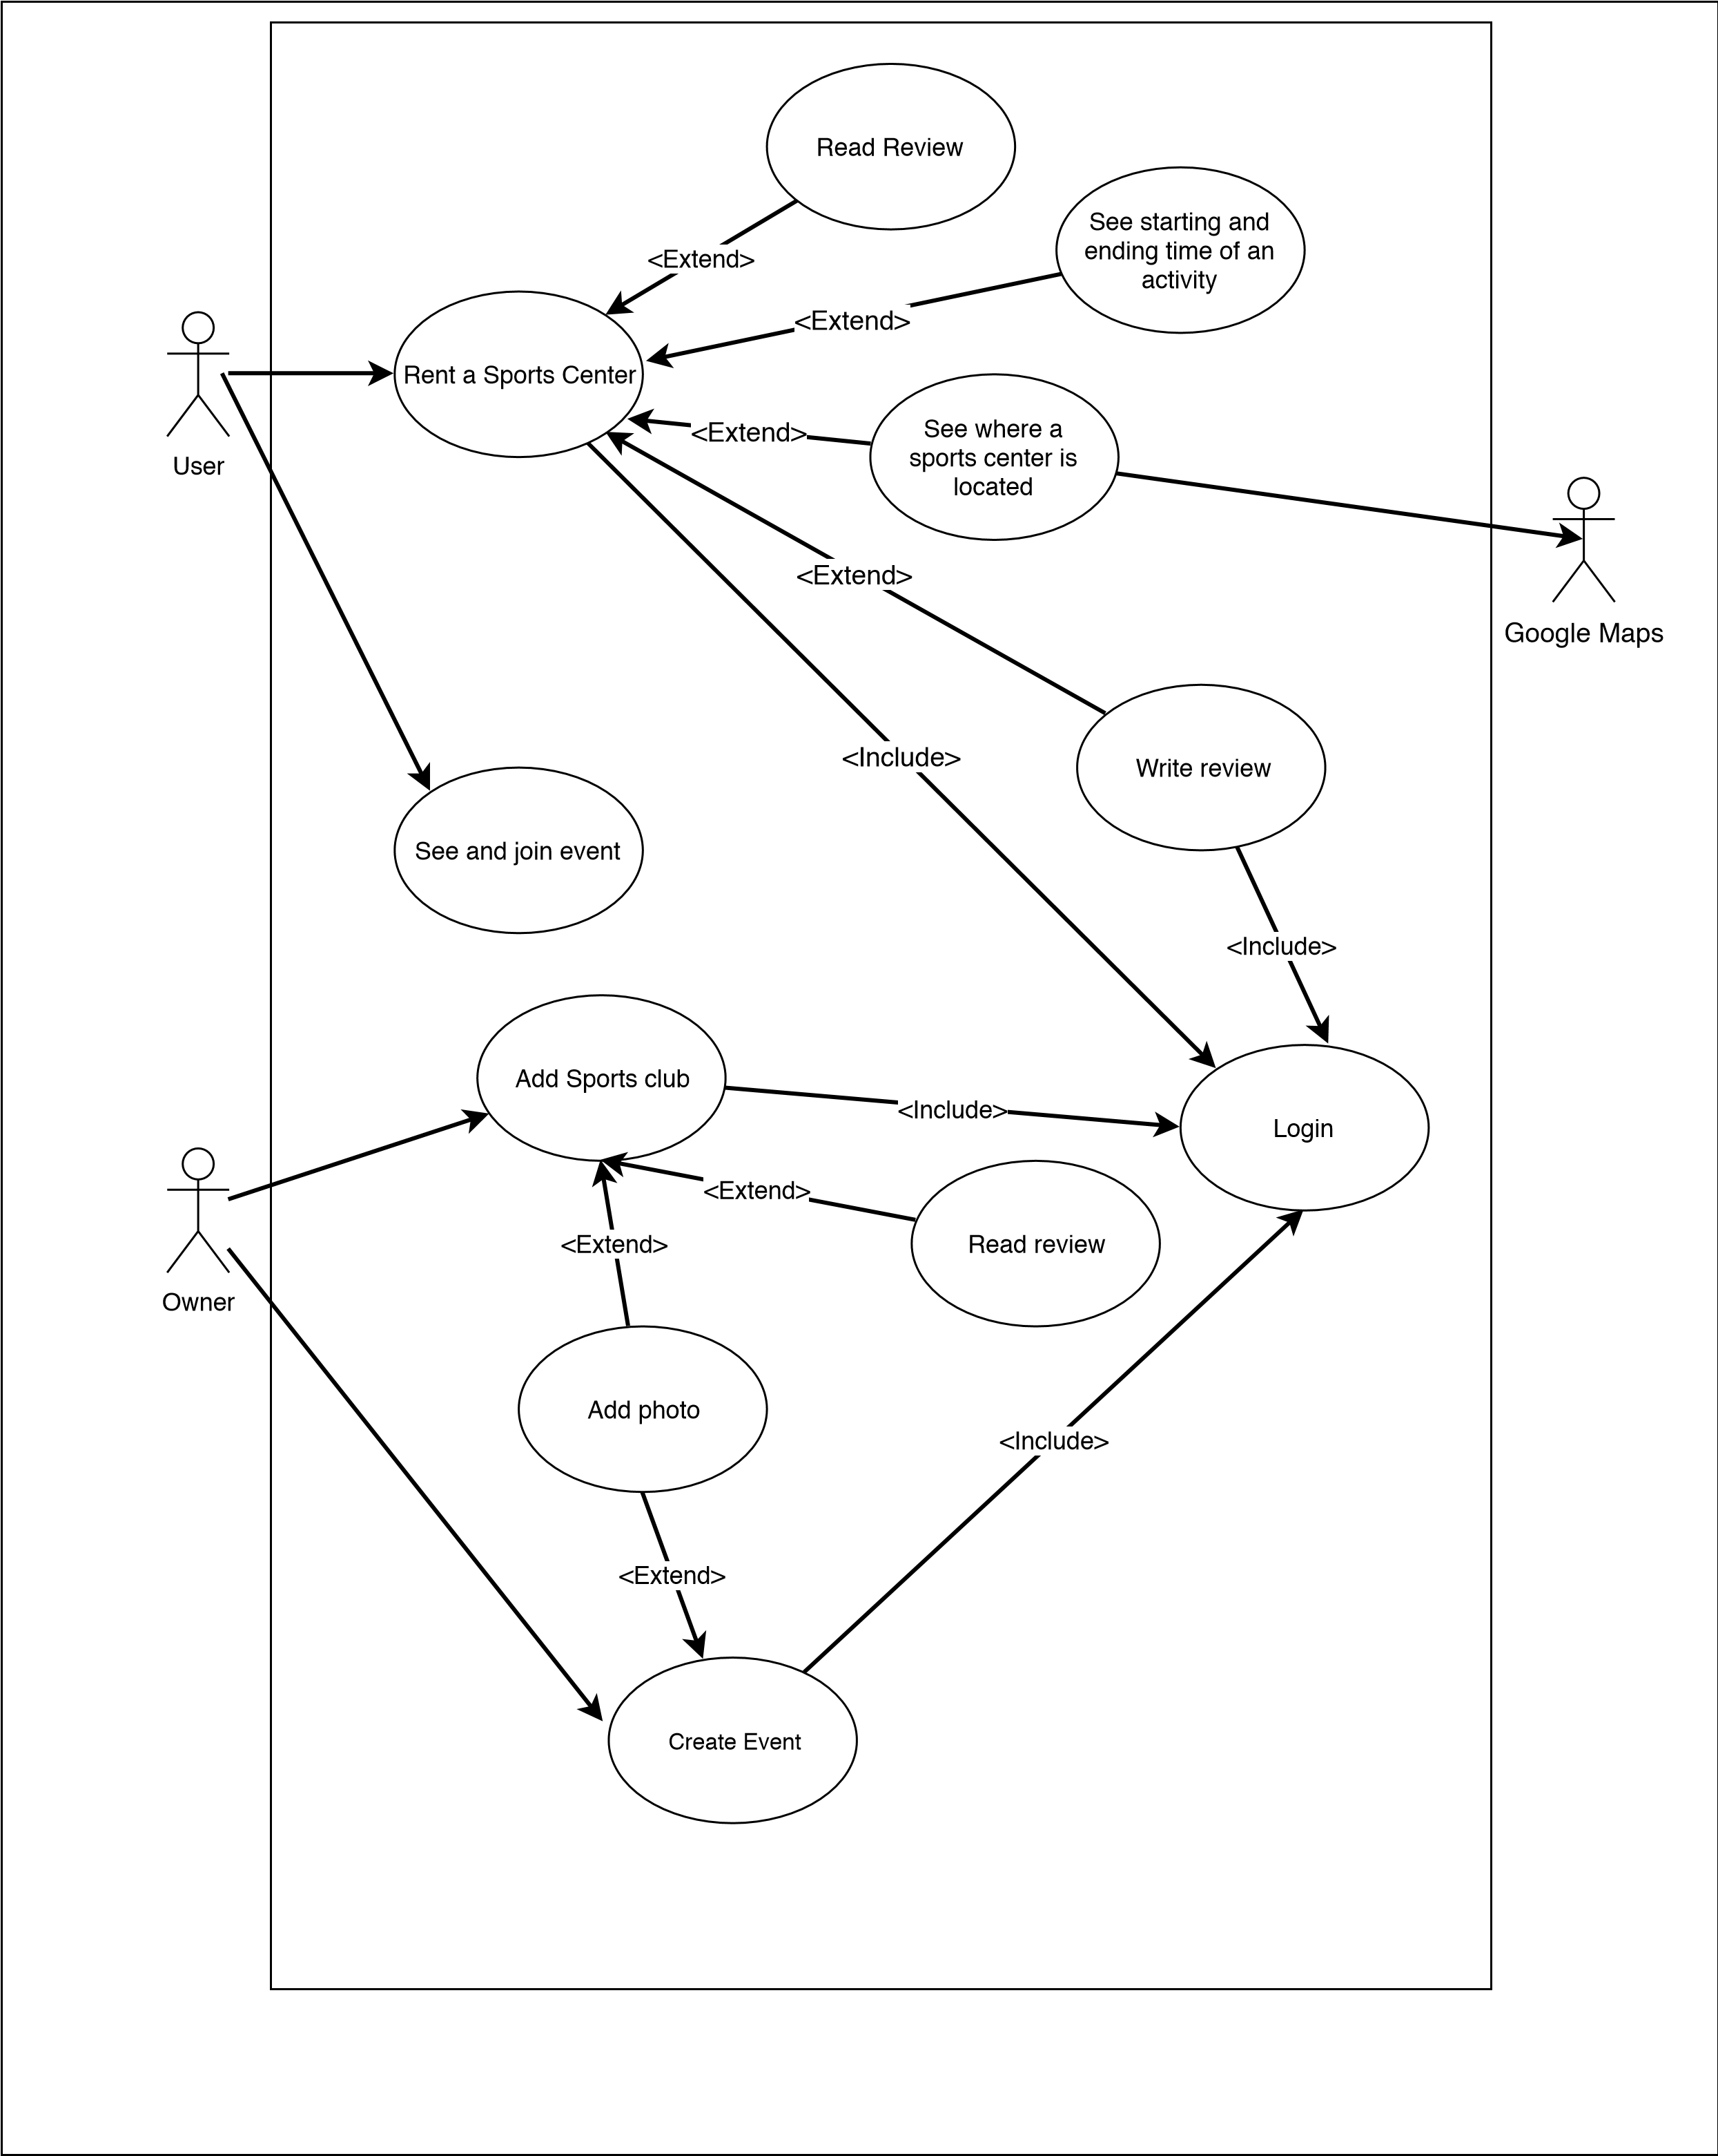USE CASE DIAGRAM